Log into your IBX Portal using your credentials.
Click on your Medical Plan
Choose “Skip to Dashboard” below the 4 boxes of icons:
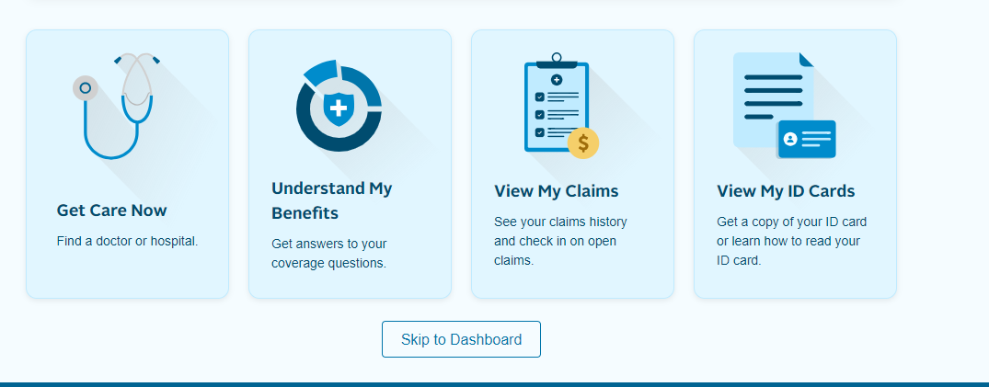
On the left side menu bar choose Claims & FinancesSpending Accounts. Choose Continue that you acknowledge being redirected to an external site.

Once you are on the Spending account site, choose the 3 bar menu at the top left of the screen and choose Spending AccountsAccount Activity
Those claims that are ready to pay should be at the top of the list with an “Action Required” status: If not, filter on Status to bring up Action Required items: Look for the claim you wish to pay, using Transaction Date as a guide (this will be the date of service)

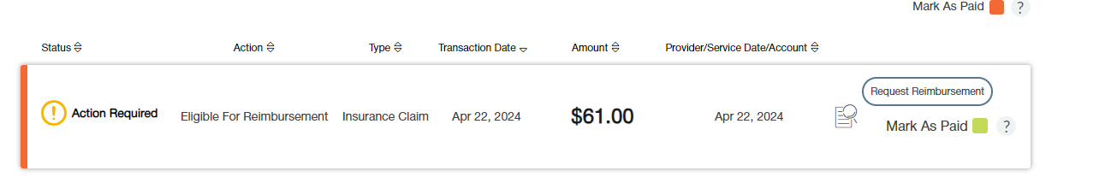
Choose “Request Reimbursement”

Make sure “Pay Provider” is highlighted as shown in yellow below:
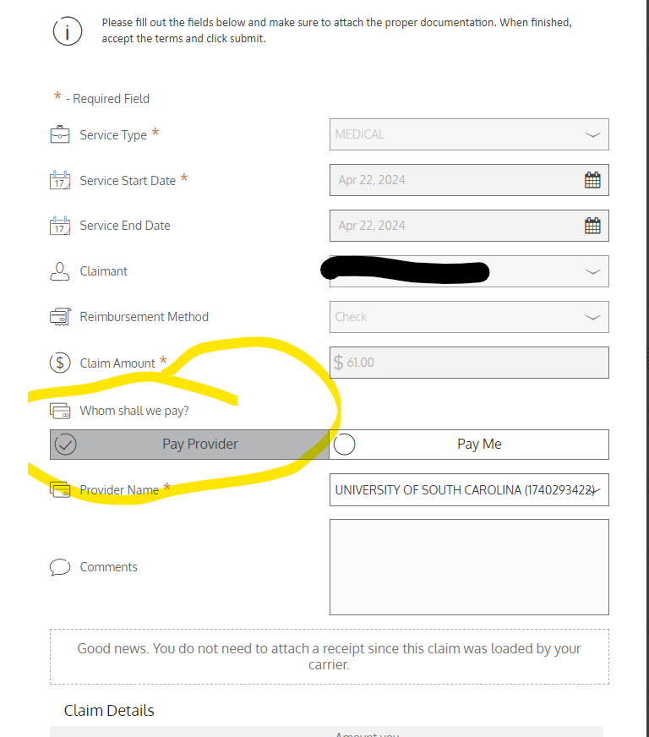

Choose NEXT at the bottom of the screen and confirm you abide by the yellow box and choose submit.

